- Zinbwave
Zero-Inflated Negative Binomial Model for RNA-Seq Data:
Implements a general and flexible zero-inflated negative binomial model that can be used to provide a low-dimensional representation of single-cell RNA-seq data. The model accounts for zero inflation (dropouts), over-dispersion, and the count nature of the data. The model also accounts for the difference in library sizes and optionally for batch effects and/or other covariates, avoiding the need for pre-normalize the data.
https://bioconductor.org/packages/release/bioc/html/zinbwave.html
- Trena:Asha
Fit transcriptional regulatory networks using gene expression, priors, machine learning:
Methods for reconstructing transcriptional regulatory networks, especially in species for which genome-wide TF binding site information is available.
TReNA is a package for inferring relationships between target genes and their candidate regulators. By using TReNA, we can generate hypotheses around regulation of gene expression and enable the construction of gene network models.
http://bioconductor.org/packages/release/bioc/vignettes/trena/inst/doc/TReNA_Vignette.html
- SCnorm: robust normalization of single-cell RNA-seq data.
SCnorm groups genes based on their count-depth relationship and within each group applies a quantile regression to estimate scaling factors to remove the effect of sequencing depth from the counts.
http://bioconductor.org/packages/release/bioc/vignettes/SCnorm/inst/doc/SCnorm.pdf
- GENIE3:Kevin
GEne Network Inference with Ensemble of trees:
Inferring Regulatory Networks from Expression Data Using Tree-Based Methods.
GENIE3, a new algorithm for the inference of GRNs that was best performer in the DREAM4 In Silico Multifactorial challenge. GENIE3 decomposes the prediction of a regulatory network between p genes into p different regression problems. In each of the regression problems, the expression pattern of one of the genes (target gene) is predicted from the expression patterns of all the other genes (input genes), using tree-based ensemble methods Random Forests or Extra-Trees.
http://journals.plos.org/plosone/article?id=10.1371/journal.pone.0012776
- Rexposome:
Exposome exploration and outcome data analysis:
Package that allows to explore the exposome and to perform association analyses between exposures and health outcomes.
- BISCUIT: Bayesian inference for single-cell clustering and imputing
Provides a method for the iterative normalization and cluster of single-cell gene RNA-seq expression data. BISCUIT eases clustering of cells based on similar gene expression after correcting technical variation. The software uses a Bayesian model and employs a model driven by covariance structures for the normalization and the input of data. These functionalities are appropriate to work on tumor heterogeneity and other primary tissue to understand novel cell types.
https://bioconductor.org/help/course-materials/2017/BioC2017/Day2/InvitedSpeakers/Biscuit_Azizi.pdf
- scRNA-seq: Single-cell RNA sequencing
A powerful and promising class of high-throughput assays that enable researchers to measure genome-wide transcription levels at the resolution of single cells.
- Leveraging Bioconductor for somatic variant analysis of TCGA data:
This process demonstrates the use of the Bioconductor GenomicDataCommons package to identify and then fetch somatic variant results from the NCI GDC and then provide a high-level assessment of those variants using the maftools package.
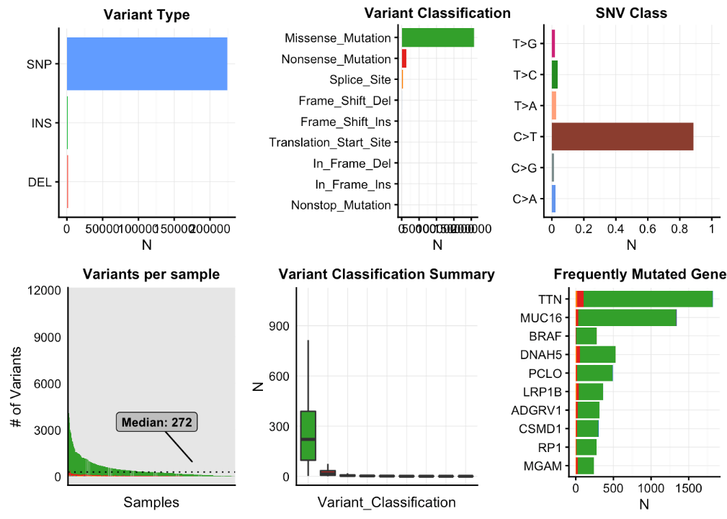
- Phenopath: Kevin
Genomic trajectories with heterogeneous genetic and environmental backgrounds:
PhenoPath infers genomic trajectories (pseudotimes) in the presence of heterogeneous genetic and environmental backgrounds and tests for interactions between them.

